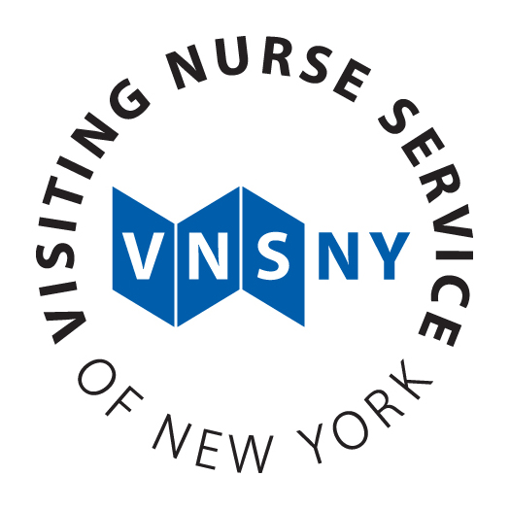 | Information Technologies  Technical Specification

<Platform/Application> Specification
<Project Name>
<IT Project Code>
<Version Number>, <Date>

Application Design and Development

Contents

Contents 2
Document History 3
1. Overview 4
2. Architecture 4
3. Project Artifacts 5
4. Data Requirements 5
5. Inventory 6
6. Code Quality and Testing 6
7. Dependencies 7
8. Security Requirements 8
9. Deployment/Update History 8
10. Disaster Recovery 8
11. Specification Sign Off

Document History

Name | Date | Description | Version

1. Overview
Provide a project description including a short summary, project IDs and team members. It should reference other project related documents including the project scope and functional specification documents as appropriate.
The following should be clearly indicated in this section:
- Project Id and Description.
- Project team, title, and responsibilities.
- Vendor information if third party software is included as part of the project

2. Architecture
Describe all architecture, software, and hardware components utilized during the development, including all relevant information such as vendors, versions, etc…
This section may contain the following:
- Technologies/Frameworks
- Platform Tools
- Configuration settings for development tools and environments.
- Logging, audit trail and associated reporting functionality available through application

3. Project Artifacts
Identify and include all development related artifacts needed to build the application. They can be directly embedded in this document or the content referenced from this document.
Examples of items that may be found in this section are:
- User Interface Design mockups
- Program Function descriptions.
- Process Workflow(s)
- Diagrams – objects, mappings, various visual representations
- Interface Diagram
- Report Templates
- Future development and design components/concerns

4. Data Requirements
Identify and include all data related artifacts that are utilized within the application. These artifacts may be directly embedded in this document or the content referenced from this document.
Examples of items that may be found in this section are:
- Database Models and Entity Relationship Diagrams (ERD)
- Database components – table names, columns, data types, indexes, triggers, views, stored procedures, and referential integrity.
- Database transaction management techniques.
- Data record layouts
- File inputs and outputs
- DB2 Database Request IDs

5. Inventory
Identify source code components and repositories that make up the application. These artifacts may be directly embedded in this document or the content may be referenced from this document.
Examples of items that may be found in this section are:
- Programs, components, classes, and JCL/Procs/Jobs
- Source code repository – Endevor, CVS, Microsoft Visual SourceSafe, etc…

6. Code Quality and Testing
Identify all code quality and testing procedures that are used during the development build process. These artifacts may be directly embedded in this document or the content may be referenced from this document.
Examples of items that may be found in this section are:
- Coding conventions.
- Code reviews
- Unit testing. (See Template at the end of the Technical specification document) If your unit testing scenarios and results are documented in an automated tool, please indicate here and specify what tool.

7. Dependencies

Identify all application related dependencies both internal and external. Examples of items that should be in this section are:
- Third party software – LDAP, commonware.
- APIs
- Interface with non-VNS systems – e.g. Medicare/Medicaid clearance, Security agencies, and Google maps.

8. Security Requirements

Identify all security related policies and processes that are addressed in this specification. Security requirements needed to support the implementation of the changes contained herein must be included in this document or referenced separately in a related security policy.
Examples of items that should be covered in this section are:
- Application accessibility – internal/external, VPN, SSL, etc..
- Have you followed the guidelines provided in the OWASP Top Ten Most Critical Web Application Security Risks. (https://www.owasp.org/index.php/Top_10_2010) or a similar security framework appropiate for your platform ? Please Describe.
- Authentication and access control.
- Protection against vulnerabilities – SQL injection and cross-site scripting.
- HIPPA concerns.

9. Deployment/Update History
This section is intended to cover all application updates such as bug fix updates and enhancements. This section should contain all relevant detail associated with the update.

Examples of items that may be covered in this section are:
- Description and Date of deployment.
- Cross references with Change Management requests and Help Desk Tickets.

10. Disaster Recovery
This section is intended to cover all application updates such as bug fix updates and enhancements. This section should contain all relevant detail associated with the update.

Examples of items that may be covered in this section are:
- Service level recovery requirements.
- Data backup requirements.
- Data Retention requirements.
11. Specification Sign off
*** This section needs additional discussion with Gil, is it needed in the technical document? Is N/A appropriate? ***

<<Project Name>> All requirement based development has been completed by the IT Application Development team(s) and submitted for review and approval. On approval, this document will certify that all required development has been conducted and that all known exceptions have been acknowledged, reviewed, and documented with approval given by all project stakeholders. This document will be included with all other project documents to be used as the basis for testing and acceptance of the final system.

I have reviewed the technical specification results and acknowledge that the information contained herein meets the objectives and expectations for this project.

Sign off must be obtained by the Development Lead(s) completing the specification from the Project Manager, the analyst who developed the requirements specification, the Security team, the Infrastructure team, the Testing Manager, and the Training Manager

Project Role | Name | Date

Development Manager
Development Manager
Development Manager
Project Manager

Unit Test Plan

Process/Function: | Objective:

Category/ Condition | Condition Description | Step | Step Description | Test Data | Expected Results | Actual Results | Comments | Tester & Date

